Wrapping Up Pattern Two

* **a name for the pattern: Favorites**
* **a wireframe picture**

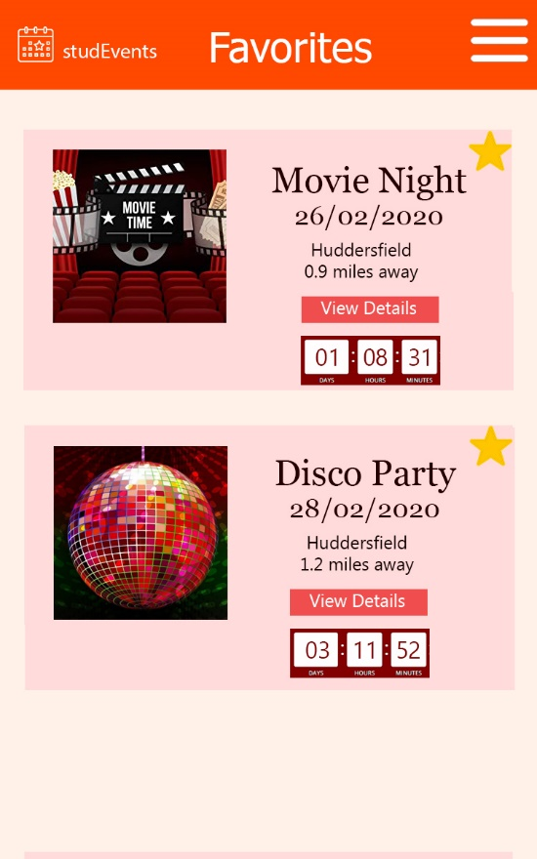

* **use when** (describes when the pattern should be applied)

1.Use to enable users to differentiate between large amounts of content items

2. Use to enable users customize their own lists of data

* **how** (describes how the pattern may be applied)

This pattern will be applied to make a list of events that were selected by user as favourites. It’s main functionality is to save time by differentiating the content. The user will be able to go to his favourite event in just few clicks.

* **a discussion of** how you have applied this pattern in your own information seeking.

I am applying this pattern to keep track of specific information. For example, I might create a list of favorite items and keep in touch with every update. If it’s a light novel, I am keeping track of the number of chapters, to read the new chapters as soon as they appear. Also, this pattern helps a with differentiating the items, so I don’t need to remember which light novel I read, I just use this search pattern to find my customized list.